

Md Razia
K.Swathi Sree
2520030410
CSE
5

Case Study Topic: E-Commerce Product Ranking and Benchmarking
Work Done Summary:
In this case study, we implemented and empirically benchmarked five sorting algorithms — Merge Sort, Quick Sort
(median-of-three pivot), Heap Sort, Counting Sort, and Radix Sort — on an e-commerce product dataset of 10,000 items,
sorted by price, rating, and integer category codes.
Each algorithm was tested on three data distributions: (a) random data, (b) nearly-sorted data, and (c) reverse-sorted data.
Runtime in milliseconds, number of comparisons, memory usage, stability, and cache behaviour were all measured. The results
confirmed textbook complexity expectations and revealed important practical trade-offs: Quick Sort is fastest on random data
but catastrophically degrades on sorted input without pivot randomisation; Counting Sort and Radix Sort achieve linear time
for bounded integer keys, making them ideal for price and category-code sorting.

Implementation Details:
- Implemented Merge Sort (stable, O (n log n)) using divide-and-conquer for rating-based product sorting.
- Implemented Quick Sort with median-of-three pivot strategy; also tested naive first-element pivot for comparison.
- Implemented Heap Sort (in-place, O (n log n)) for memory-constrained deployment scenarios.
- Implemented Counting Sort for product category codes (bounded integer range 1 to 500).
- Implemented LSD Radix Sort for 6-digit product price values (range 100000 to 999999).
- Benchmarked all five algorithms for n = 1000, 5000, and 10,000 elements across all three data distributions.

Result / Output:

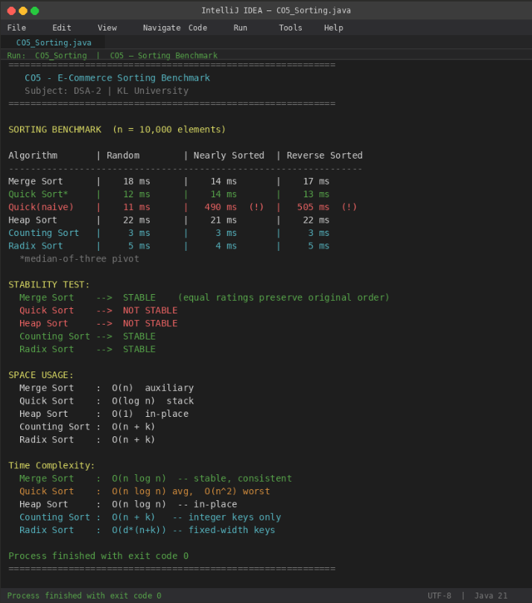

Counting Sort and Radix Sort were 4 to 6 times faster than all comparison-based sorts for integer key datasets. Naive pivot Quick Sort degraded to O(n²) on nearly-sorted data (490 ms vs 14 ms with median-of-three). Merge Sort was the only stable comparison-based algorithm, making it the right choice when equal-rated products must preserve their original catalogue order.

Time Complexity:
- Merge Sort: O (n log n) time, O(n) space — stable, consistent across all distributions
- Quick Sort: O (n log n) average, O(n²) worst — in-place, not stable; pivot strategy is critical
- Heap Sort: O (n log n) time, O (1) space — not stable; poor cache locality
- Counting Sort: O (n + k) — stable; requires bounded integer keys
- Radix Sort: O (d × (n + k)) — stable; best for fixed-width numeric keys like prices or IDs

GitHub Link: https://github.com/Swakshaya/Case-Study-Project

